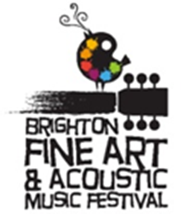

You are invited to participate!
The Brighton Fine Art and Acoustic Music Festival is the weekend of August 4 - 6, 2017! The Guild will have a 30’x10’ tent in front of the CoBACH building* and each artist is encouraged to:
- Bring up to two pieces of art to hang in the Guild’s main gallery;
- Bring up to 10+ smaller-sized pieces (priced $100 and under) for the boutique section;
- Use art bins and tables provided for miscellaneous, smaller items (notecards, prints, etc.), that can be replenished as needed throughout the Festival.
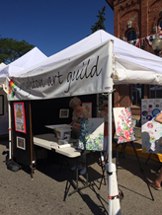This is a grrreat opportunity to have your art seen and appreciated by an art loving crowd of 30,000 at a wonderful summer Festival, in a prime location in Brighton.
This Festival opportunity is set up to benefit YOU, the artist! Entry is free and you receive a generous 80% on all your art sales; remaining 20% goes to support our Guild. All that is required is 3 hours of your time helping with the Guild Festival activities such as: sitting in CoBACH to help with sales/ miscellaneous needs; working in the tent to answer questions/ keep it tidy; helping with intake, setup or takedown; demonstrating your medium (a big crowd pleaser) or helping with another Guild event tent next to CoBACH that displays the artworks created during the Guild’s Paint Out weekend (July 22 & 23rd).
Intake of Festival Art will be Wednesday, August 2nd (our regular monthly meeting) but please note it will be at CoBACH instead of the Brighton Library. Take down will be 4pm-5pm Sunday, August 6th. Festival hours are Friday, August 4, 5pm--8pm; Saturday, August 5, 10am-8pm; Sunday, August 6, 10am-4pm.
Event sign up sheets for sitters and demonstrators will be available at the July 12 general meeting. (Note the change of date from the first Wednesday in July to the second.) Inventory and exhibitor information is available on the Guild’s website under the Exhibits&Events tab, Art Festival. Guild website address is: www.brightonartguild.com. Please contact Mary Lou Wiegand (Weegan) at 304-415-0023 or artist.scribe@gmail.com with any questions or sitter/demo sign up requests. If you want to participate but can’t make the meeting just give me a call!

*The CoBACH Building is a red brick building next door to the Yum Yum Tree. Yum Yum Tree’s address is: 140 W. Main Street, Brighton, MI

