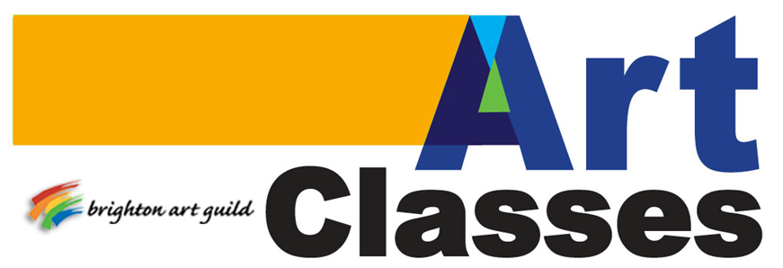
2015 Winter Schedule

To register, contact the artist listed for each class.
Checks for classes taught at the CoBACH Center are to be written to the Brighton Art Guild.
For further information and images related to the classes listed visit the Guild website at www.brightonartguild.com

Heather Harrison

Art Paper Scissors
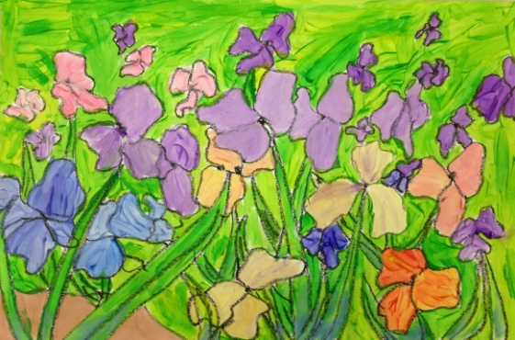
Art Paper Scissors is a home-based art studio that offers homeschool and after-school art classes in 6-week sessions for youth and teens. Classes are held in Heather’s home studio conveniently located near downtown Brighton. Heather has 10+ years experience teaching youth. She is a member of the National Art Education Association and the Michigan Art Education Association.
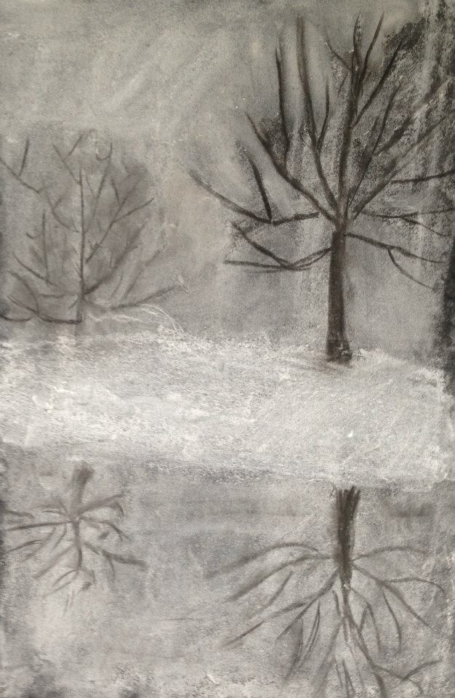

Contact: Heather Harrison
cell: 810-623-7534 e-mail: deccah@gmail.com
Facebook Page: www.facebook.com/artpaperscissors
Tuition: $10/student per class, or $50 for all 6 classes.

Art Class Schedule:
Mondays: 10:00—11:30am (youth); 1:00—2:30pm (tween/teen)
Tuesdays: 1:00—2:30pm (tween/teen); 4:30—6:00pm (youth)
Wednesdays: 1:00—2:30pm (youth); 4:30—6:00pm (youth)
Thursdays: 10:00—11:00am (Mommy & Me); 1:00—2:30pm (youth); 4:30—6:00pm (tween/teen)

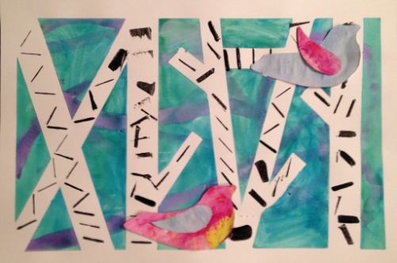
Winter Classes Session 1
January 19th- February 26th
Week 1: Jan 19-22 (drawing)
Week 2: Jan 26-29 (painting)
Week 3: Feb 2-5 (prints/collage)
Week 4: Feb 9-12 (textiles)
Week 5: Feb 16-19 (3-D/sculpture)
Week 6: Feb 23-26 (TBD)

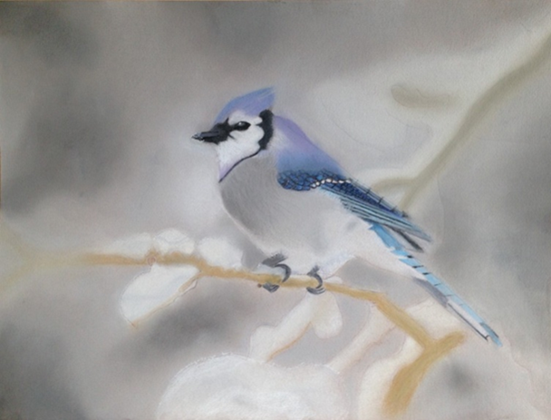

Winter Classes Session 2
March 9—April 24
Week 1: Mar 9-12 (drawing)
Week 2: Mar 16-19 (painting)
Week 3: Mar 23-26 (prints/collage)
Week 4: Mar 30-Apr 2 (textiles)
NO CLASSES APRIL 6-9
Week 5: Apr 13-16 (3-D/sculpture)
Week 6: Apr 20-24 (TBD)

Youth Art Classes (ages 6+)
Tween/Teen Art Classes (ages 10+)
Students will explore drawing, painting, sculpture, textiles, print-making, collage, etc. in a comfortable and fun studio setting. Some of the media available: watercolor, tempera & acrylic paint, chalk & oil pastels, air-dry and modeling clay, wire sculpture, needle felting, weaving, print-making, art from recycled materials, etc.
Mommy & Me (ages 5 and younger + parent)
Thursdays, 10:00am, $5/student per class. Developmentally-appropriate art activities for exploration and learning fun.

Private & Semi-Private Lessons
Private and semi-private lessons are offered for serious students. Cost is $15/hour. Curriculum and schedule is mutually determined by instructor and student.

► Life Drawing Opportunities: For all experience levels
When: Every Tuesday. Noon - 3:30 p.m.
Where: Howell Opera House 123 W. Grand River, Howell 48843 517-540-0065
Cost: Live model fee -$10.00
Materials: Bring your own supplies

